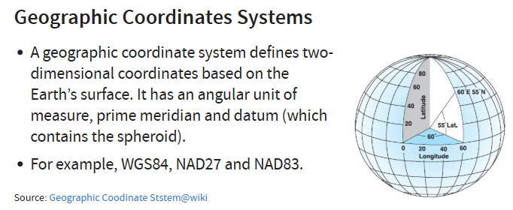
Global coordinates, not good to measure distance and area because 1 degree at the equator will be different as compared to 1 degree at the north pole. Planes will not fly across horizontally because it is further. Rather they fly up (nearer to north pole) then back down as that will be less in term of distance.

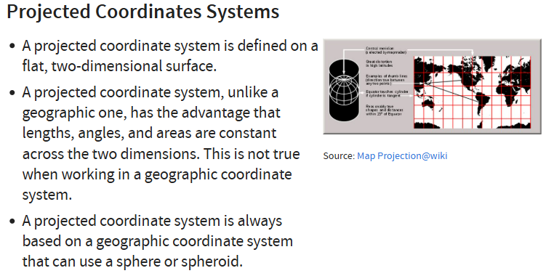

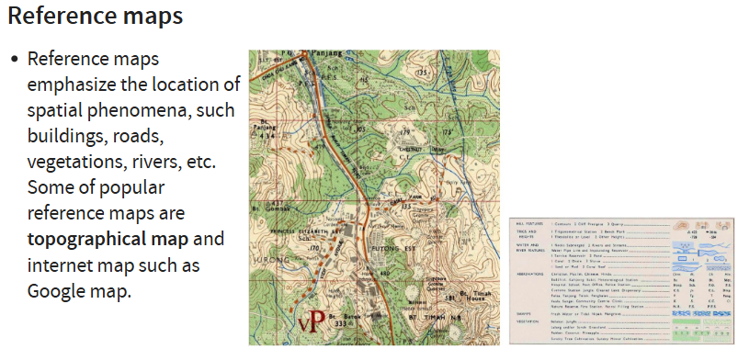

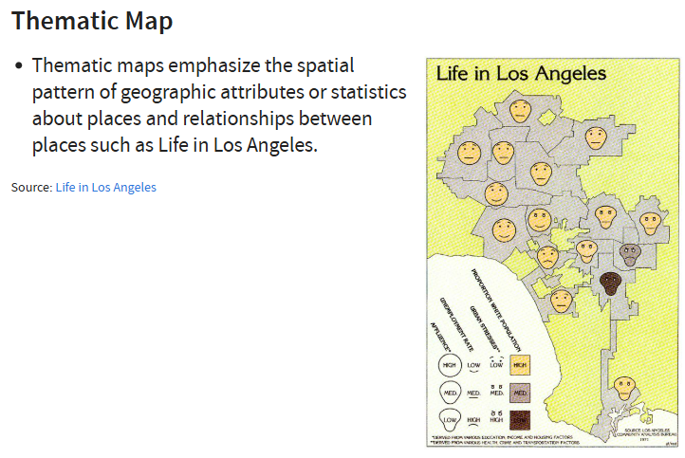
Differentiate spatial entity into different theme

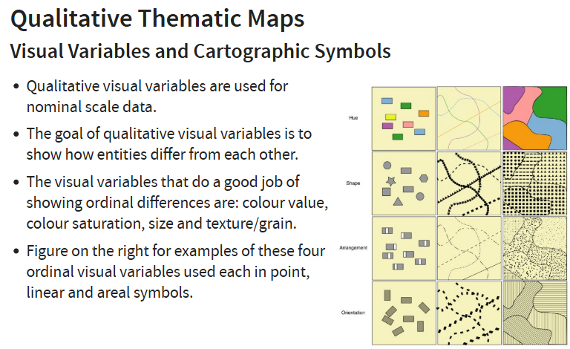
Know whether it is point, line or polygon
Point: size and colour, shapes

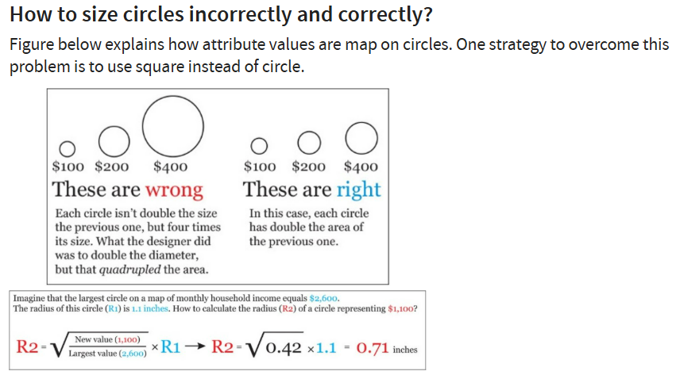

Polygon won’t overlap but point and lines will overlap.
If there is overlap, make sure the bigger object is at the back, and smaller object is in front (plot big ones then plot the small ones) using RULES.
Otherwise, can just play with the level of opacity. 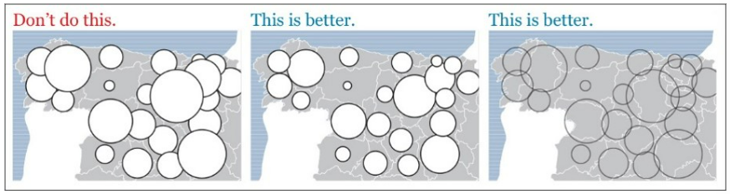

To show intensity we can use:
- Bricks map (quantitative information plotted using number of bricks proportionately)
- Dot density map (using density of dots)
- Choropleth (uses shading or patterns) 5-8 classes is max, too many and might not be visually effective anymore. Use shades of one colour

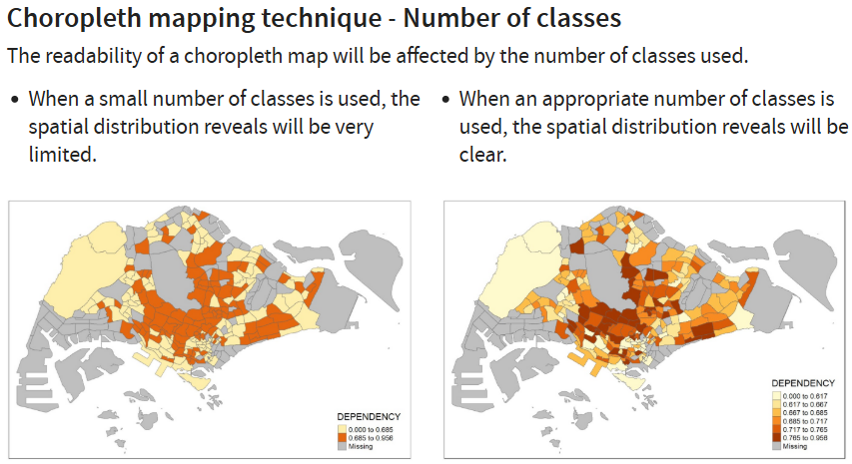

IN CLASS EXERCISE (TABLEAU)
Use SGPools_wgs84.csv
Right click Xcoord > geographic role > longtitude, Ycoord to latitude
Drag Xcoord to columns and Ycoord to rows, name to detail and Gp1Gp2Win to colour
Change opacity and select border colour for circles

For postal code it has to be 6 digits, make sure it is character type so that all 6 digits are kept. Some areas e.g. Chinatown have postal codes starting from 0 and if it is numeric type, it will automatically be truncated, leaving it as a 5 digits instead.

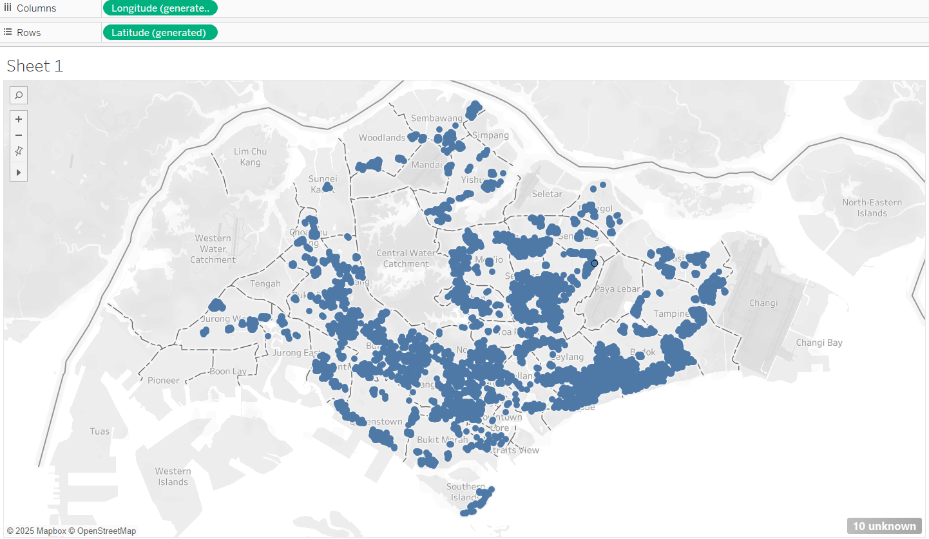
Just drag postal code to the main area and drop, it will automatically plot
There are 10 unknown locations, can edit
If not can right click and hide indicator so that people won’t know there are missing values

